<Form 1>
2nd half of 2025 PIURI Post-Doc. Fellowship Application
(Fellowship Period: 2025. 9. 1. ~ 2027. 8. 31.)
Applicant  Information | Name |  |  | Date of Birth (YYYY/MM/DD)
Applicant  Information | Title of Research Project
Applicant  Information | Education (All your bachelor’s and higher degrees)
Applicant  Information | Period | School | Major |  | Degree |  | Date of Completion
Applicant  Information | Title of Doctoral Thesis
Applicant  Information | Contact | E-mail
Applicant  Information | Contact | Phone | -
Application field | 1. Basic Science 2. Engineering 3. Information Technology  ※ Select one field that best suits your research topic.
Recommending Professor | 1) Name :  2) Department : POSTECH Dept. of  3) Contact(Phone) :  4) E-mail :
Appointment period  &  Annual Salary | 20 . . . ～ 20 . . .  ※ Fellowship will be supported from the start of Fellowship or Appointment—whichever comes after, until the end of Fellowship or Appointment—whichever comes earlier. If the applicant is not appointed, the Fellowship will be canceled. |  | ￦  ※ Amount of support from the Recommending Professor  (Excluding the Fellowship and Department support)
Appointment period  &  Annual Salary |  |  | ￦  ※ Amount of support from the Department  (Excluding the Fellowship and Recommending Professor’s support)
20 . . .
Applicant: (Name) (Signature)
Recommending Professor: (Name) (Signature)
* Please attach CV(Curriculum Vitae) and one copy of Ph.D diploma
<Form 2>
Letter of Recommendation
Name of  Applicant |  | Date of Birth  (YYYY/MM/DD)
Title of Research Project
* Size of this cell can be modified

I recommend the above applicant as a highly qualified academic researcher for the PIURI Post-Doc. Fellowship, and will take the responsibilities as the Recommending Professor until the end of the fellowship period.

- The applicant’s research space is provided by the Recommending Professor.
- The applicant’s annual salary (Number) KRW is provided by the Recommending Professor. (Excluding Fellowship and Department support)

20 . . .

Recommending Professor
Department:
Position: Name: (Signature)
※ Recommending Professor must consider the applicant’s employment status, etc., before the recommendation to ensure that applicant is able to participate in research at POSTECH. (Regular/Full-time employee of another institution is not eligible to apply for the fellowship.)
<Form 3>
Letter of Commitment

If the applicant (Name) is selected for the 2025 2nd half PIURI Postdoctoral Fellowship, the following support is committed during the fellowship period. (Name of Department) Department will provide (Number) KRW annually to the applicant. (Excluding Fellowship and Supervising advisor support)

20 . . .

(Name of Department) Department

Dean of (Name of Department) : (Name) (Signature)

<Form 4>
Name |  |  |  |  | Ph.D Acquisition Date
Research Achievements | Affiliation  (Duration) |  |  | Current Affiliation:  ___________________  (YYYY/MM/DD  ~ YYYY/MM/DD) |  |  | Previous Affiliation:  ___________________  (YYYY/MM/DD  ~ YYYY/MM/DD)
Research Achievements | Research Projects Undertaken  (your share of the profits in KRW) |  |  | Within institution: |  | Outside institution: | Within institution: | Outside institution:
Research Achievements |  |  |  | (KRW ) |  | (KRW ) | (KRW ) | (KRW )
Research Achievements | Academic Publications Records | International Journal (Total) |  | Count:  (Total IF: , Total Citation: ) |  |  | Count:  (Total IF: , Total Citation: )
Research Achievements | Academic Publications Records | First or  corresponding Author |  | Count:  (Total IF: , Total Citation: ) |  |  | Count:  (Total IF: , Total Citation: )
Research Achievements | Academic Publications Records | National Academic Journal |  | Count: |  |  | Count:
Research Achievements | Academic Publications Records | International Conference  (*computer science-related) |  | Count:  (*Total Citation: ) |  |  | Count:  (*Total Citation: )
Research Achievements | Academic Publications Records | National Conference |  | Count: |  |  | Count:
Research Achievements | Number of Books |  |  | International: ,  National: |  |  | International: ,  National:
Research Achievements | Number of Patents |  |  | International: ,  National: |  |  | International: ,  National:
Research Achievements | Other Research Achievements
Others | Awards
Others | Other Activities
Summary of Achievements

※ In the research achievements section, please state the total number of achievements, not the full title of the journal/conference/book/etc.

YYYY. MM. DD.
(Signature)

<Form 5>
<List of achievements
(From Most to Least Important)>
Date of Publi-cation | Title of Thesis | Journal |  |  |  | Role  (First, Corres-ponding,  Co-author)
Date of Publi-cation | Title of Thesis | Journal | Impact  Factor | Journal Rankings By Category  (S2journal) |  | Role  (First, Corres-ponding,  Co-author)
 |  |  |  | Category Name | Rank | Role  (First, Corres-ponding,  Co-author)
0000.  00.00. | * Number of rows can be modified | 0000 | 00 |  | /
 |  |  |  |  | /
 |  |  |  |  | /
 |  |  |  |  | /
 |  |  |  |  | /
 |  |  |  |  | /
 |  |  |  |  | /
 |  |  |  |  | /
* Please attach an evidential material for each achievement (The first page of paper or abstract / Certificate)
* Please write the impact factor (IF) based on the journal publication year. If the IF for the publication year has not yet been announced, write the most recent IF.
* Role Distinction: If you are a co-first author or a corresponding author, you need to indicate your order/total number of co-first authors or corresponding authors in parentheses (e.g., Co-first author (1/2) or Corresponding author (2/2)).
<Form 6>

Collection and use of personal information

In relation to the 2025 2nd half PIURI Postdoctoral Fellowship, we would like to collect and use personal information as follows. After fully understanding the following contents, please check whether you agree to the collection and use of your personal information.

<Collection and use of personal information contents>
Items | Purpose of  collection and use | Collection/use period
Name, date of birth, academic background, contact information (cell phone, email), period of appointment, annual salary, research achievements, recommending professor information (name, affiliation, contact information, email) | PIURI Selection | 5 years

※ You have the right to refuse consent to the collection and use of personal
information. However, if you refuse consent, PIURI selection may be limited.
☞ Do you agree to the collection and use of personal information as above?
- Disagree □ Agree

20 . . .
Applicant: (Name) (Signature)

How to Check the Journal Rankings by Category
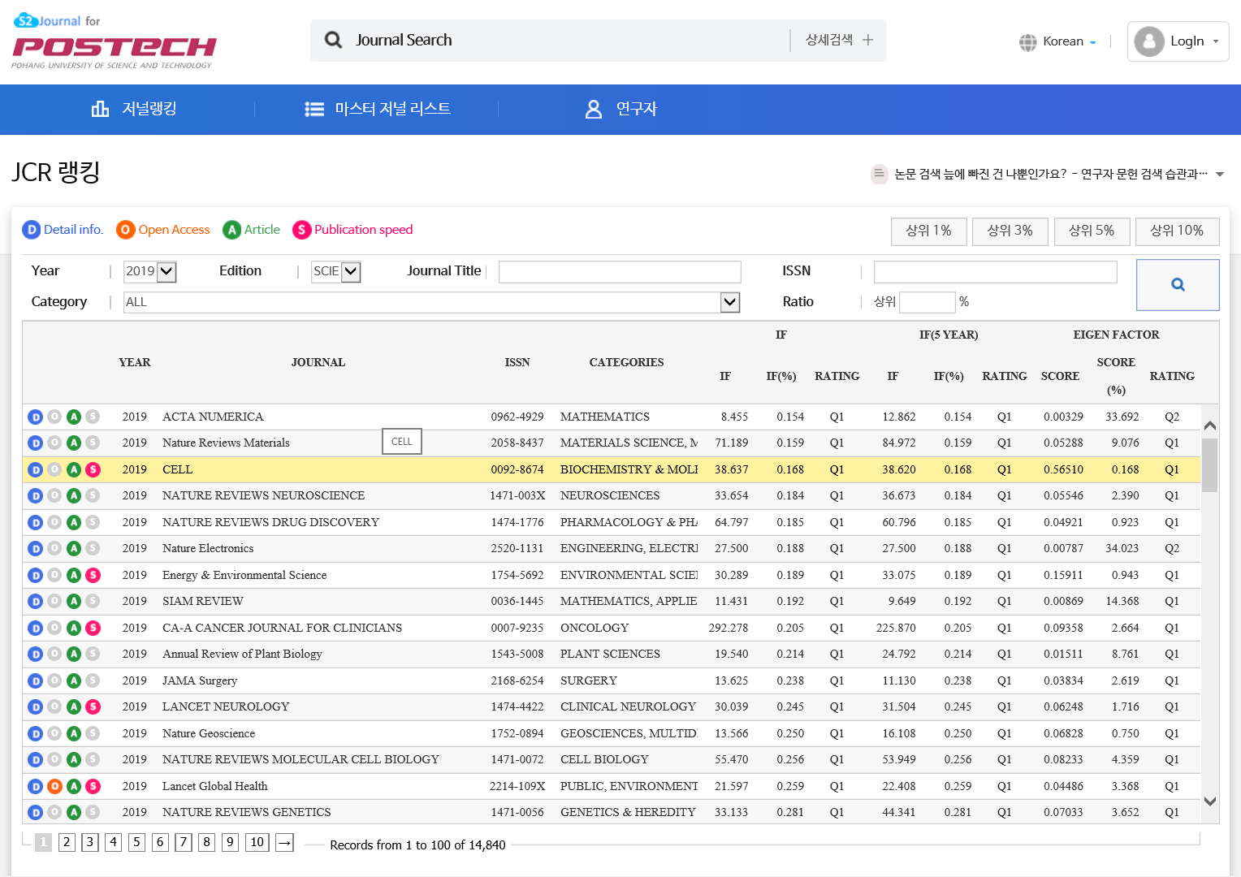
https://s2journal.bwise.kr/jcr/jcrCategoryRankingPage.do
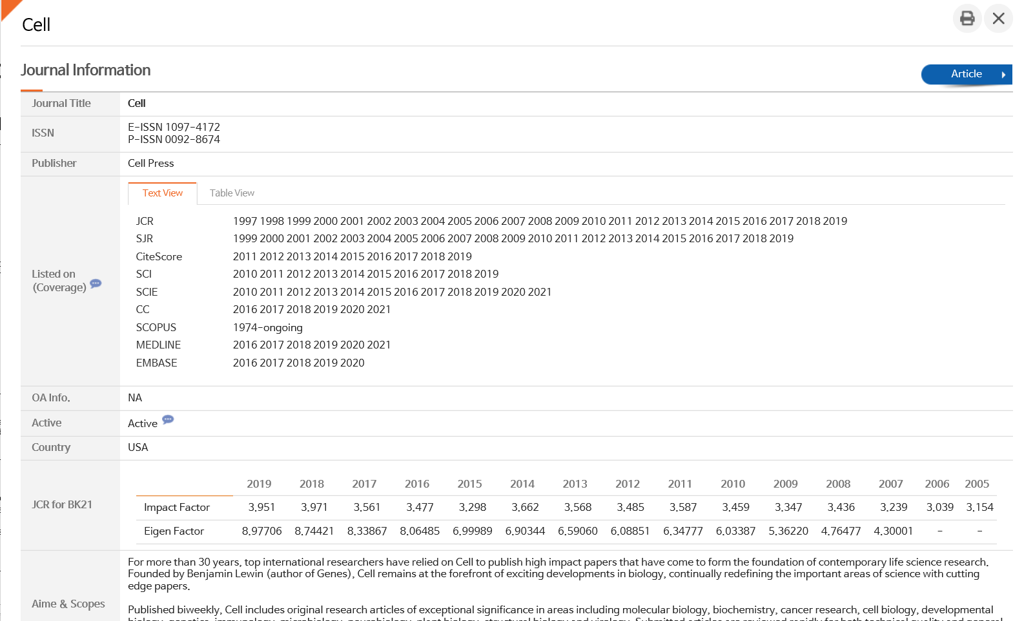

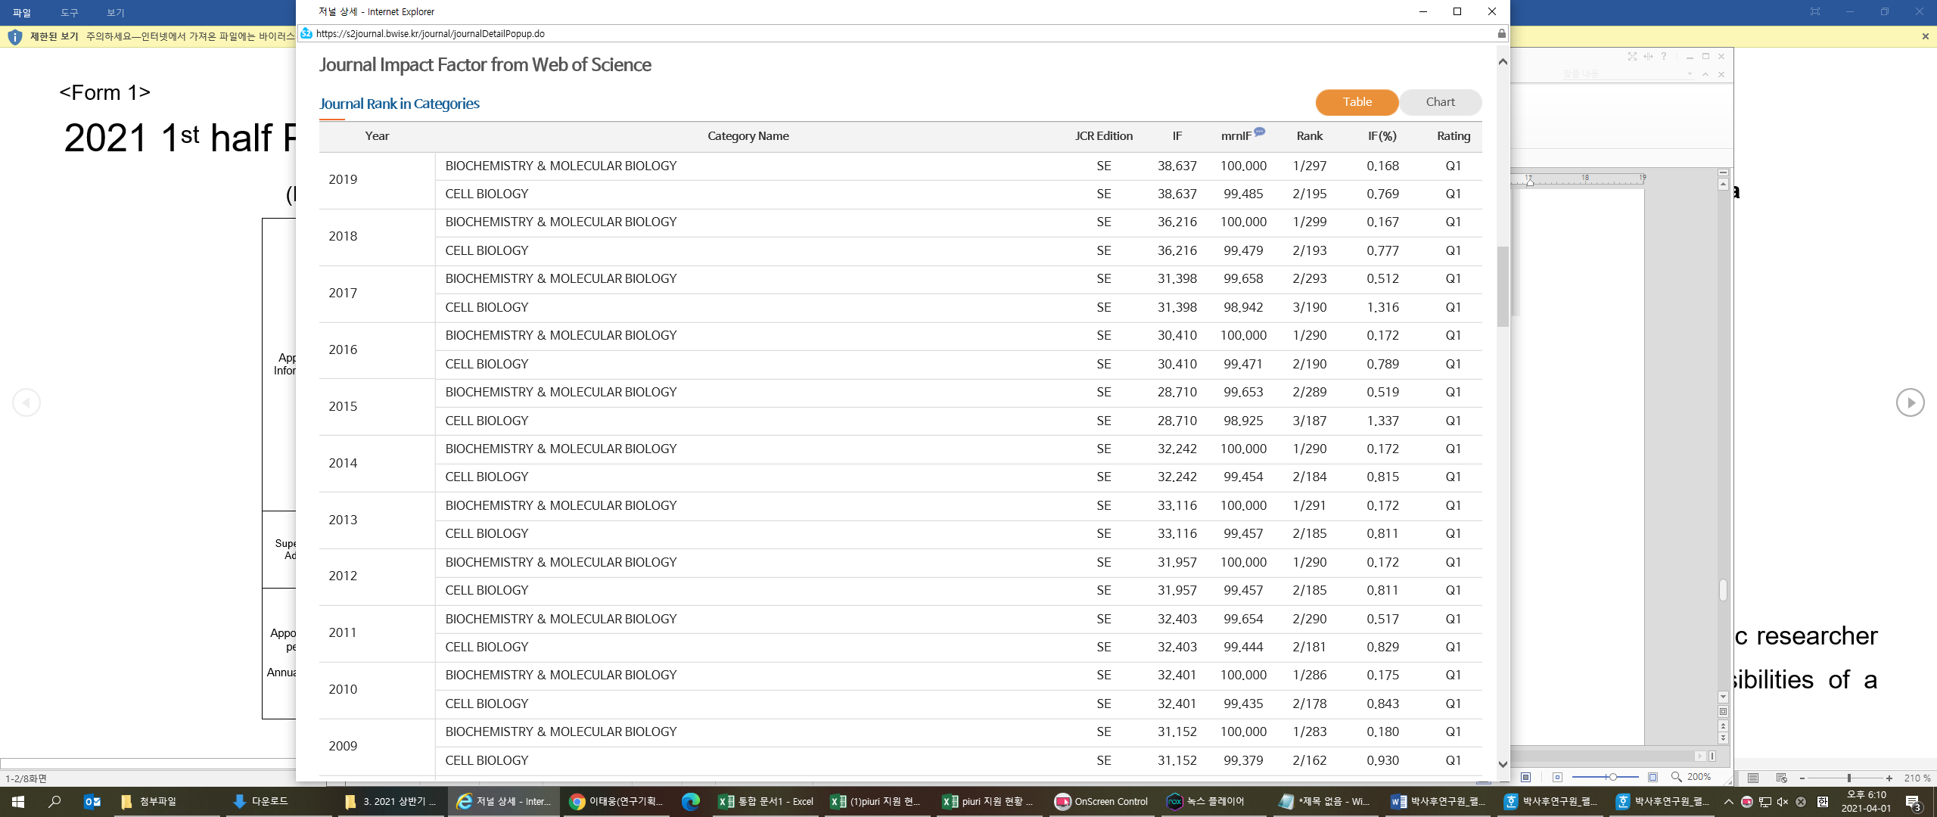
- It must be submitted as JCR ranking for fair evaluation (Other site rankings such as Scopus are not accepted.)

